HB12 ATAR – Test 3 IMMUNITY KEY

Part A: Multiple Choice (20 marks) TOTAL 60 MARKS

DO NOT MARK THIS PAPER IN ANY WAY.

FOR MULTIPLE CHOICE ANSWERS PLACE AN X ON THE LETTER OF YOUR CHOICE ON THE ANSWER SHEET PROVIDED.

1. Which of the following BEST defines pathogens?

- Bacteria and fungi.
- Bacteria, fungi and viruses.
- Bacteria, fungi and viruses that cause disease.
- Organisms that cause disease.

2. Macrophages present in the blood are responsible for:

- manufacturing antibodies.
- engulfing foreign cells or particles.
- aiding in the clotting of blood.
- detoxifying harmful substances.
3. The human skin
(a) acts as a specific defence mechanism.
(b) carries helpful bacteria that aid in defending against other pathogenic bacteria.
(c) specifically excludes antigens once an individual is immunised against them.
(d) is made waterproof by secretions from the sweat glands

4. A vector is:

- a disease – causing micro-organism
- an insect which becomes infected with a disease
- a person who does not suffer from a disease but may transmit it to others.
- an organism which transmits disease from one person to another.

5. Substances stimulating the production of antibodies are called:

- toxins
- antigens
- carcinomous bodies
- antitoxins

6. Which of the following statements is INCORRECT?

- bacteria can survive outside living cells.
- some fungi can cause disease in humans.
- all bacteria are pathogenic.
- viruses can only multiply inside cells of living organisms.

7. Which of the following cannot produce an active immunity to a disease organism?

- a dose of the disease
- antibodies in breast milk.
- an injection of dead bacteria.
- an injection of weakened virus.

8. THREE of the statements below are true for BOTH antibodies and phagocytes. Which statement below is true for ANTIBODIES ONLY?

- They are involved in neutralising an antigen.
- They are involved in protecting the body against foreign micro-organisms.
- They are complex compounds but are not living cells.
- They pass through the walls of blood vessels to a site where micro-organisms have entered the body.

9. What is the main difference between antibiotics and antivirals?

- Antibiotics are safer to use than antivirals.
- Both are effective against bacteria.
- Antibiotics are effective against bacteria and antivirals are not.
- Both are effective against viruses.

10. The graphs below show the effect of two injections of an antigen on the formation of an antibody.
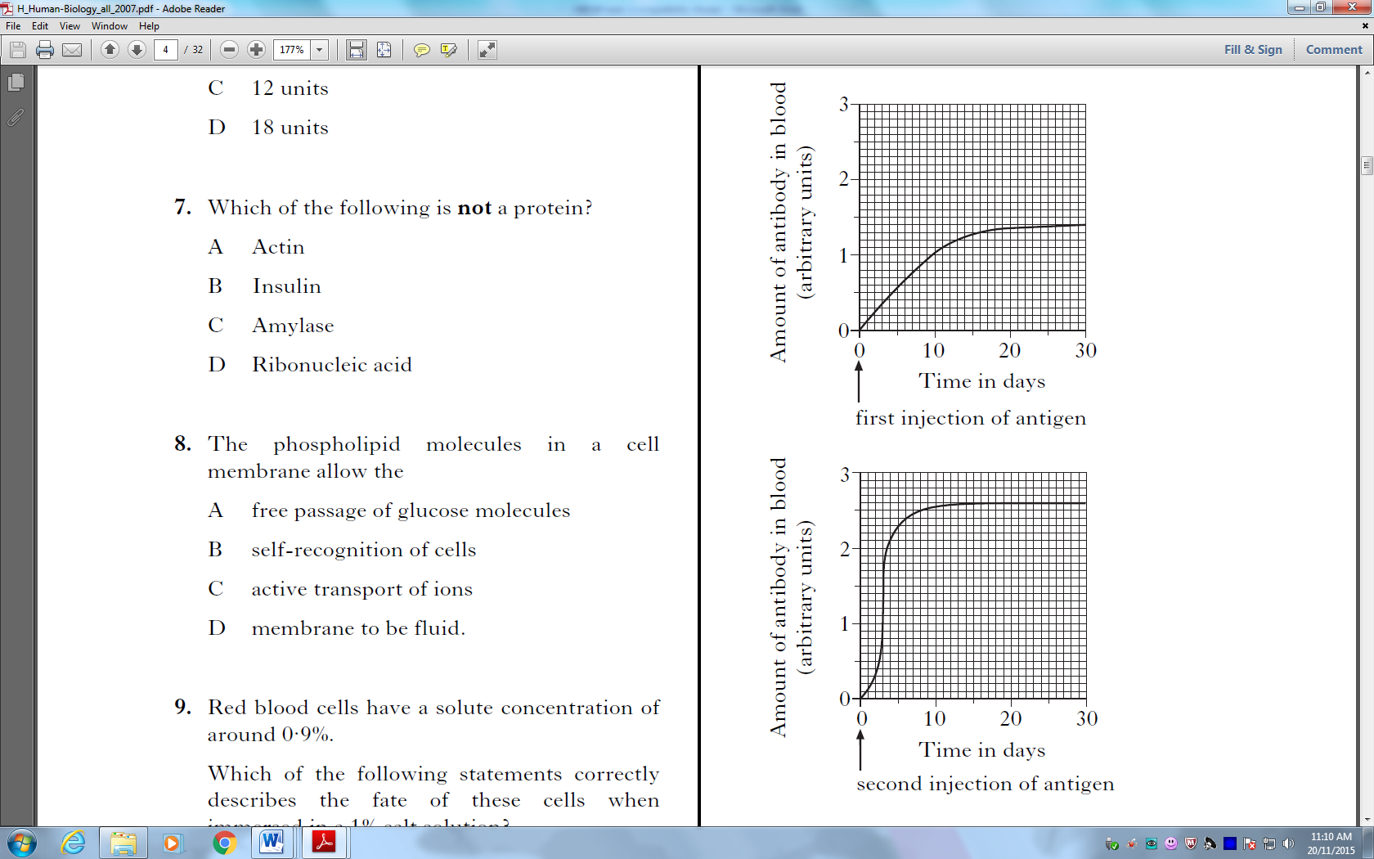

Which of the following statements is not supported by the data in these graphs?

- The secondary response provides a longer period of protection
- Only the secondary response will provide protection from the disease
- The secondary response is faster than the primary response
- The secondary response produces more antibodies than the primary response
11. Which one of the following statements about antibodies is correct?
a) They combine with antigens to form compounds which protect the body against
bacteria or viruses.
b) They combine with phagocytes to form cells resistant to invading particles.
c) They are produced in response to the stimulus of bacteria and viruses entering the body.
d) They are produced by antigens present in the body.

12. An individual has been inoculated with a particular antigen. Three weeks later the inoculation is repeated. One would expect that after the second inoculation, antibodies specific to the antigen:
a) are produced more quickly and in greater quantity than after the first.
b) are produced more quickly but in smaller quantity than after the first.
c) are produced more slowly but in greater quantity than after the first.
d) are not produced in any quantity if the antibodies from the first are still present in abundance.

13. Phagocytes are best described as:
a) complex chemical compounds consisting of molecules with large numbers of atoms.
b) arrangements of protein molecules with digestive properties similar to enzymes.
c) living cells which reproduce rapidly at points of bacterial invasion.
d) living cells able to ingest bacteria and cell pieces.

14. The “killer” cell or “T-lymphocyte” cell is part of the:
a) non-specific immune system.
b) inflammatory response.
c) antibody mediated response.
d) cell-mediated response.

15. An antigen is a substance that:
a) is called a toxin or a virus.
b) is found on the surface of viruses.
c) is found in bacteria.
d) produces an immune response.
16. How does immunisation against diseases such as diphtheria and polio limit the spread of these infectious diseases?
a) Immunisation kills the relevant pathogens.
b) Immunisation suppresses or reduces the immune response and associated inflammation.
c) Immunisation strengthens first-line defence barriers and prevents the entry of the relevant pathogens into the body.
d) Immunisation reduces the multiplication of the relevant pathogens in immunised hosts and this reduces the chance of other people becoming infected.
17. Measures such as protective clothing, gloves and surgical masks help reduce the risk of infections by

  - sterilising the surrounding air
  - providing an alternative pathway for invading pathogens
  - providing a mechanical barrier that acts as an obstacle to invading pathogens
  - signalling to others that the protected person may be carrying a disease
- Topical preparations to prevent or treat infections are those which are applied

- orally
- to surfaces around the home such as kitchen benches
- to relieve pain
- the skin
- Which of the following is not a component of the body’s external defence against disease?
  - wax in the ears
  - alkaline conditions in saliva
  - layers of mucus in the respiratory tract
  - acid environment in the urethra

- Which of the following is not a strategy people can undertake to help to reduce the spread of disease?

- wearing surgical masks
- covering their mouths when coughing
- wiping surfaces with disinfectant
- taking pain relief drugs

MC ANSWERS
1 D, 2B, 3B, 4D, 5B, 6C, 7B, 8C, 9C, 10B, 11C, 12A, 13D, 14D, 15D, 16D, 17C, 18D,19B, 20D.

PART B: Short answer section (30 Marks)

16. Describe four ways pathogens can be transmitted and for each, give an example of a pathogen that can be spread that way. [4 marks]

- CONTACT OR TOUCHING EG SYPHILLIS
- INHALING OR BREATHING EG COLDS
- INGESTION OR EATING EG CHOLERA
- VECTORS OR OTHER ANIMALS EG MOSQUITOES SPREADING MALARIA

17. Describe four of the body’s external defences and explain how they protect us from disease. [4 marks]

- PHYSICAL DEFENCES INCLUDE IMPERMEABLE BARRIERS (EG SKIN), FLUID MOVEMENT THAT WASHES PATHOGENS AWAY (EG BLEEDING, URINE FLOW, SWEATING) AND PHYSICAL TRAPS SUCH AS HAIRS, CILIA AND MUCUS
- CHEMICALS DEFENCES KILL PATHOGENS OR SLOW THEIR GROWTH. EXAMPLES INCLUDE ENZYMES IN TEARS, SWEAT, SALIVA AND DIGESTIVE SYSTEM, ACIDS IN VAGINA, URINE AND STOMACH.
- SKIN HAS AN IMPERMEABLE LAYER OF CELLS AND SECRETES SWEAT AND SEBUM THAT DESTROY BACTERIA.
- DIGESTIVE SYSTEM HAS ACID AND ENZYMES THAT DESTROY BACTERIA
- UROGENITAL SYSTEM HAS ACIDIC URINE
- RESPIRATORY SYSTEM HAS MUCUS, CILIA AND MUCOUS MEMBRANES
- EYES HAVE LIDS, LASHES AND EYEBROWS. TEARS CONTAIN ENZYMES THAT DESTROY BACTERIA
- EARS HAVE MUCOUS MEMBRANES, HAIR AND EAR WAX.

18. The diagrams below show a disease-causing virus and one of the same type which has been weakened to make it less harmful.

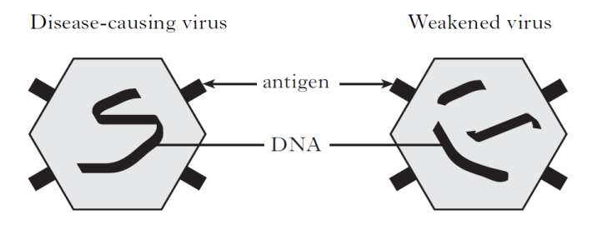

- What do we call pathogens that have been weakened in this way? [1 mark]
ATTENUATED

- A woman is vaccinated with the weakened form of the virus.
- What feature of the weakened virus results in her gaining immunity from the disease? [1 mark]

ANTIGEN CAUSING A SPECIFIC IMMUNE RESPONSE

- Describe two risks associated with using this type of vaccine [2 marks]

SOME PROBLEMS SEEN WITH VACCINATIONS ARE SIDE EFFECTS EG ALLERGIC REACTIONS, PEOPLE ACTUALLY GETTING THE DISEASE, AND SHORT EFFECTIVENESS OF SOME OLDER VACCINES SO RE-IMMUNISATION IS NEEDED

- What is a vaccine and describe one other method of producing vaccines and give an example of a vaccine produced this way [4 marks]

DEFN VACCINES ARE PREPARATIONS OF ANTIGENS USED TO STIMULATE THE IMMUNE SYSTEM (1M)
METHODS USED TO REDUCE THE VIRULENCE OR POSSIBILITY OF SIDE EFFECTS OF VACCINES ARE TO USE RECOMBINANT DNA TECHNOLOGY TO REDUCE VIRULENCE OF PATHOGENS IN A VACCINE(2M), / OR TO PRODUCE VACCINES CONTAINING HARMLESS BACTERIA GENETICALLY ENGINEERED TO PRODUCE THE ANTIGEN OR ONLY THE ANTIGEN (NOT THE WHOLE PATHOGEN) /(2M).
EG INFLUENZA ETC (1M)

19. Vaccines exist for most of the common childhood diseases, but many people still do not have their children vaccinated.

- Describe two reasons why people should vaccinate their children

HERD IMMUNITY REFERS TO IMMUNITY LEVELS WITHIN A POPULATION. IF ENOUGH PEOPLE ARE IMMUNE (THROUGH NATURAL OR ACQUIRED IMMUNITY) DISEASE TRANSMISSION IS SLOWED.
IF EXPOSED TO THE PATHOGEN THE PERSON HAS SPECIFIC IMMUNITY
.
- Describe two reasons why people do not vaccinate their children.

SOME RISKS AND CONCERNS ABOUT THE PRODUCTION OF VACCINES INCLUDE THE SIDE EFFECTS (EG ALLERGIC REACTIONS), THE RISK OF CROSS SPECIES DISEASE INTRODUCTION AND EFFECTS OF PRESERVATIVES OR ADDED CHEMICALS IN THE VACCINES.
SOME PEOPLE CHOOSE NOT TO BE VACCINATED OR HAVE THEIR CHILDREN VACCINATED BECAUSE OF CONCERNS ABOUT THESE RISKS, RELIGIOUS BELIEFS OR IGNORANCE ABOUT THE BENEFITS OF VACCINATION OR PREVALENCE OF THE DISEASE BEING VACCINATED AGAINST
[4 marks]
20 a) Describe two changes that occur during the inflammatory response, and explain how each helps protects the human body from disease. [4 marks]

DEFN OF INFLAMMATION REDDENING OF SKIN AFTER SKIN IS BROKEN / INCREASED FLOW OF BLOOD AT SITE OF INFECTION

INFLAMMATION WORKS TO
- REDUCE THE SPREAD OF PATHOGENS
- REMOVE DAMAGED CELLS
- START THE REPAIR OF DAMAGED TISSUE
THE MAIN CHEMICALS INVOLVED ARE HISTAMINE WHICH CAUSES THE SYMPTOMS OF INFLAMMATION AND HEPARIN WHICH PREVENTS CLOTTING AROUND THE SITE OF INJURY

b) Describe four ways by which antibodies may affect bacteria. [4 marks]
- PREVENTING VIRUSES FROM ENTERING CELLS
- INACTIVATING TOXINS
- DESTROYING CELL WALLS
- CAUSING AGGLUTINATION
- REDUCING SOLUBILITY
- ATTRACTING WHITE BLOOD CELLS
- INCREASING PHAGOCYTOSIS
- ACTIVATING COMPLEMENT

- What is the difference between T cells and B cells in terms of development? [2 marks]

ABOUT HALF THE CELLS PRODUCED BY THE BONE MARROW GO TO THE THYMUS ON, WHERE THEY MATURE INTO T CELLS BEFORE BEING INCORPORATED INTO THE LYMPHOID
TISSUES . THE OTHER HALF OF THE CELLS MATURE IN THE BONE MARROW TO BECOME
B CELLS AND THEN ALSO BECOME PART OF THE LYMPHOID TISSUES . (T CELLS ARE
SO-CALLED BECAUSE THEY MATURE IN THE THYMUS; B CELLS BECAUSE THEY MATURE IN THE BONE
MARROW.) 2 M

PART C: Extended response (10 Marks)

21. Outline the specific immune response that would occur following a cold infection.
[10 marks]
B/HUMERAL/ANTIBODY AND T CELL MEDIATED RESPONSES

B CELL

B-CELLS DETECT FREE ANTIGEN
HELPER T-CELLS DETECT MACROPHAGE-PRESENTED ANTIGENS AND STIMULATE B-CELLS
THE B-CELLS THEN BEGIN TO DIVIDE OR CLONE
TWO TYPES OF B-CELLS ARE THEN PRODUCED –
PLASMA CELLS MAKE FREE ANTIBODY
MEMORY CELLS STORE INFORMATION ABOUT ANTIGEN FOR FUTURE RESPONSE (IMMUNITY

T CELL

T-CELLS DETECT FREE ANTIGEN
HELPER T-CELLS DETECT MACROPHAGE-PRESENTED ANTIGENS AND STIMULATE OTHER T-CELLS
THE T-CELLS THEN BEGIN TO DIVIDE OR CLONE
FOUR TYPES OF B-CELLS ARE THEN PRODUCED –
HELPER CELLS AID IN RECOGNITION AND ACTIVATE OTHER LYMPHOCYTES
KILLER-CELLS (CYTOLYTIC CELLS) PRODUCE CYTOTOXIC CHEMICALS WHICH KILL FOREIGN CELLS
MEMORY CELLS STORE INFORMATION ABOUT ANTIGEN FOR FUTURE RESPONSE (IMMUNITY)
SUPPRESSOR CELLS STOP THE IMMUNE PROCESS WHEN THE ANTIGEN HAS BEEN REMOVED

